|  |  |  |  |  |
| --- | --- | --- | --- | --- |
| PATIENT NAME |  | TODAY’S DATE |  |  |
| HOME ADDRESS |  | DATE OF BIRTH |  |  |
|  |  | HOME PHONE |  |  |
|  |  | CELL PHONE |  |  |
|  |  |  |  |  |

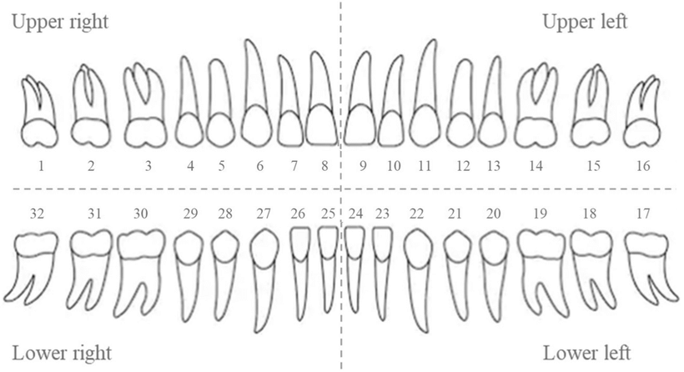

|  |  |  |
| --- | --- | --- |
| RESTORATIONS & ESTIMATE | | |
| TEETH | DESCRIPTION | FEE |
|  |  |  |
|  |  |  |
|  |  |  |
|  |  |  |
|  |  |  |
|  |  |  |
|  |  |  |
|  |  |  |
|  |  |  |
|  |  |  |
|  |  |  |
|  |  |  |
|  |  |  |
|  |  |  |